**CDGI – Transaction Tab**

1. This tab displays the transaction history of the Claim. See UI screen, same as EAW



1. The second function of is to show the field changes, who made the change and date/time stamp. Same as EAW display –

Transaction

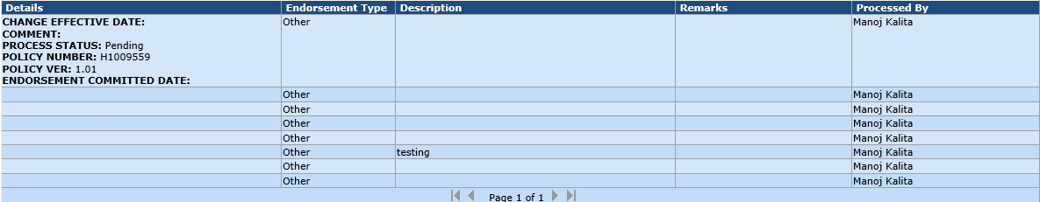

Transaction – suggest we display the tab that action was taken.

Click on any of the rows in Transaction column, the change details will be displayed –

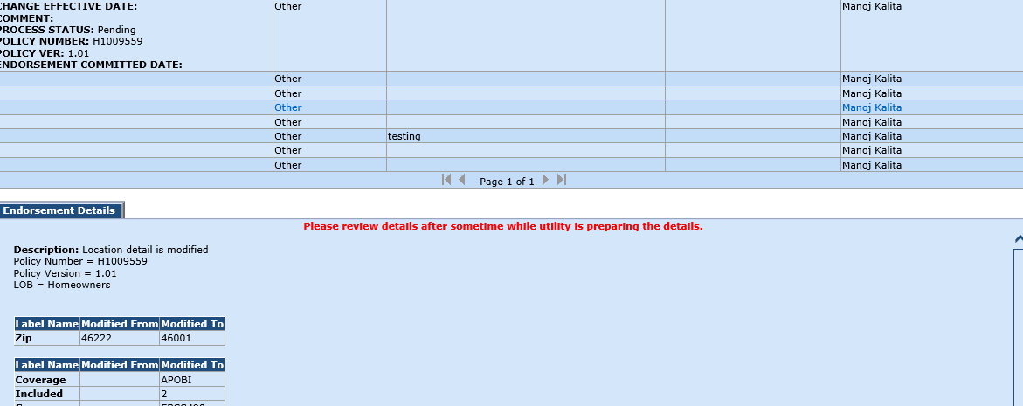

Include 2 columns – Date and Time

Transaction

**CDGI – Notes Tab**

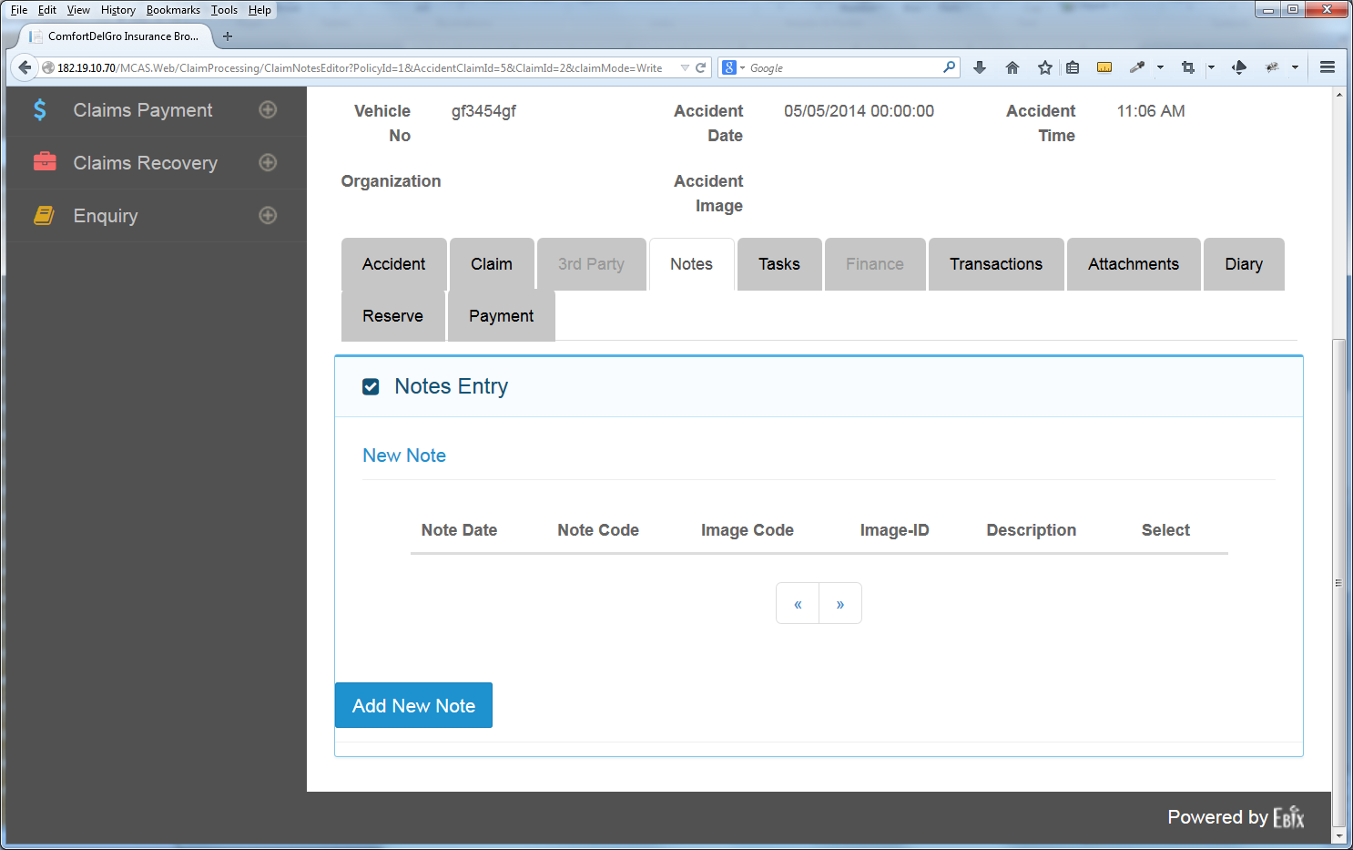

2 <Note Date & Time Set By System> <Multiline Text Field> Edit | Save | Delete

1 <Note Date & Time Set By System> <Multiline Text Field> Edit | Save | Delete